**Amazon Payments Page Board**

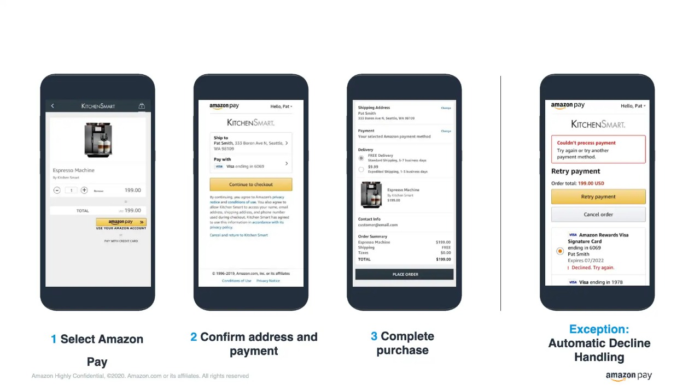

**EPIC**



**FEATURES**

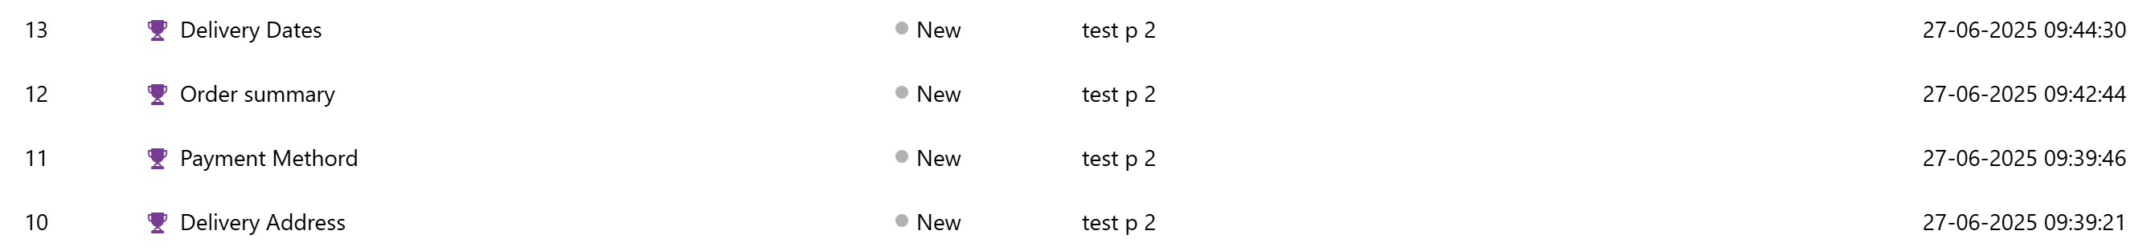

**USER STORIES**

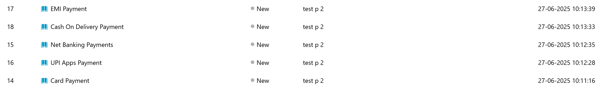

**TASKS**

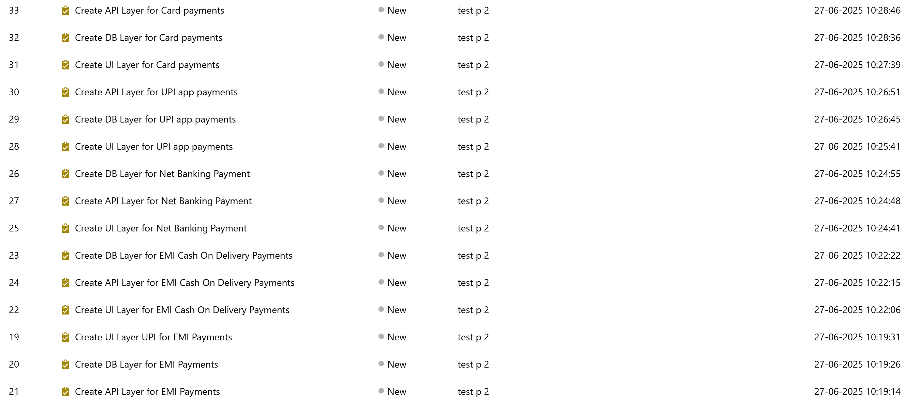

**---Aakash Gupta M**